Tuscarawas County, OH

Unique Job Benefits

**In addition to compensation and healthcare, we offer so much more!**



* **Affordable Health Insurance**Four generous coverage options including FSA & HSA plans and insurance copays for generic prescriptions as low as $10. Access to virtual medical care, as well.
* **Vision and Dental Insurance**
* **$10,000 Basic Life Policy**

With opportunity for additional voluntary coverage for self and dependents.

* **Generous Paid Time Off:**
  1. Sick – three weeks per year with rollover.
  2. Vacation – based on years of service with rollover. Two weeks at

one year of service and up to

five weeks at 25 years of service.

* 1. Personal days.
* **12 Paid Holidays; only 2 months without a holiday**
* **Longevity Pay starting at 5 years**

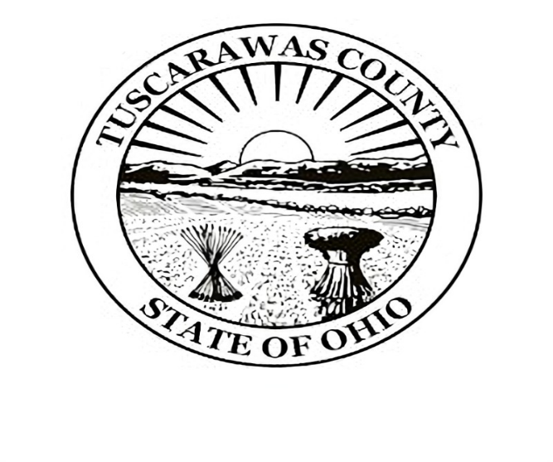



* **Wellness Program**

Preventative care & benefits including screenings, immunizations, counseling, etc. for employees & eligible dependants.



* **Employee Assistance Program**

FREE counseling services, financial and legal advice, family support, help with relationships, estate planning and more.

**Contact Human Resources to learn more or submit an application**

***Kris Lowdermilk, HR Manager*** HRManager@co.tuscarawas.oh.us

***Mellissa Clark, HR Specialist*** ClarkM@co.tuscarawas.oh.us



**330-365-3204**

* **Ohio Public Employee Retirement System**

Vested at five years of employment.

* **Deferred Compensation Program**

Program similar to 401K.